**Individual Project Report:**

* **Deep Learning:** Deep Learning is a type of machine learning in which a model learns to perform classification tasks directly from images, text, or sound.
* Deep learning is usually a neural network architecture. The term “deep” refers to the number of layers in the network – the more layers, the deeper the network.
* Traditionally neural network contain only 2 or 3 layers, while deep networks can have hundreds.
* It is actually focused on using CNNs to do image classification.
* **Convolutional Neural Network(CNNs**): CNN is a supervised deep learning method. CNN is power-full commonly used type of neural network designed for application where the input has an two dimensional network structure eg. Images
* The output layer return the strength of the networks prediction for each possible class. It return the input image into a set of features that the last few layers can use to perform the classification.
* Layers comes with many parameters known as weights.
* The weights determine how the layers behave when layers passed through them. The values of these weights are determined by training the network on label data.
* Two networks can have same architecture but behave differently if they were trained differently.
* Pretrained networks used i.e GoogLeNet and many others are like ResNet-18, Shufflenet etc.
* CNNs in MATLAB work seamlessly with image datastores.
* Image usually require simple pre-processing before they can be classified. For the whole datastore the basic pre-processing can done with “augmentedImageDatastore” function. It can also be used to convert grayscales images to RGB images.
* **Transfer Learning:**
* The process of taking pretrained network modifying it and retraining it on new data is called Transfer learning. We can build and train a network our-self starting with just the network architecture and random weights.
* But achieving reasonable results requires a lot of effort.
* Transfer learning requires same data and computer time but much less than training from scratch and the result is a network suited to our specific problem.
* For transfer learning we need three things:
* Network layers
* Training data
* Algorithm options

The algorithms can be time-tuned with many parameters such as

* How many training images to use at each step
* The maximum iterations to take.
* The learning rate etc.

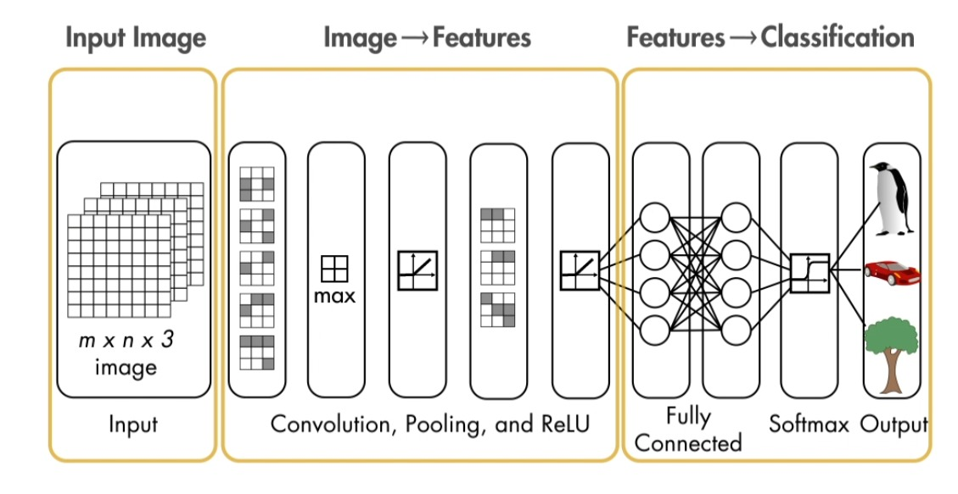

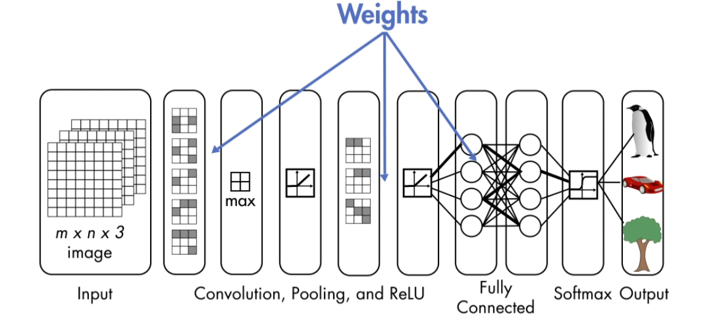

The structure of layers depends on pretrained network. The simplest type of network is called series network.

Most pretrained network is called Directed Acyclic Graphs Network or DAGs.

DAGs network have array of layers but also need a way to specify connections between those layers.

When we change the last layers then layer graph have some feature extraction behaviour as pre-trained network but it needs to be trained to map these feature to our new image classes.

A common problem with all machine learning algorithms for supervised learning is overfitting.

This is when our model does well at classifying the training data set rather than the general patterns.

One way to prevent this is to use some of our data for validation.

After updating the network on training data test the network on validation data.

**Reasons to use MATLAB for Deep Learning**

MATLAB supports ONNX to import and export models between other frameworks.

For example, A modelled designed in Pytorch for can be brought into MATLAB and models trained in MATLAB can be exported using ONNX framework.

MATLAB has specialised toolboxes and functionality specifically for reinforcement learning NLP, Automated driving.

Example:







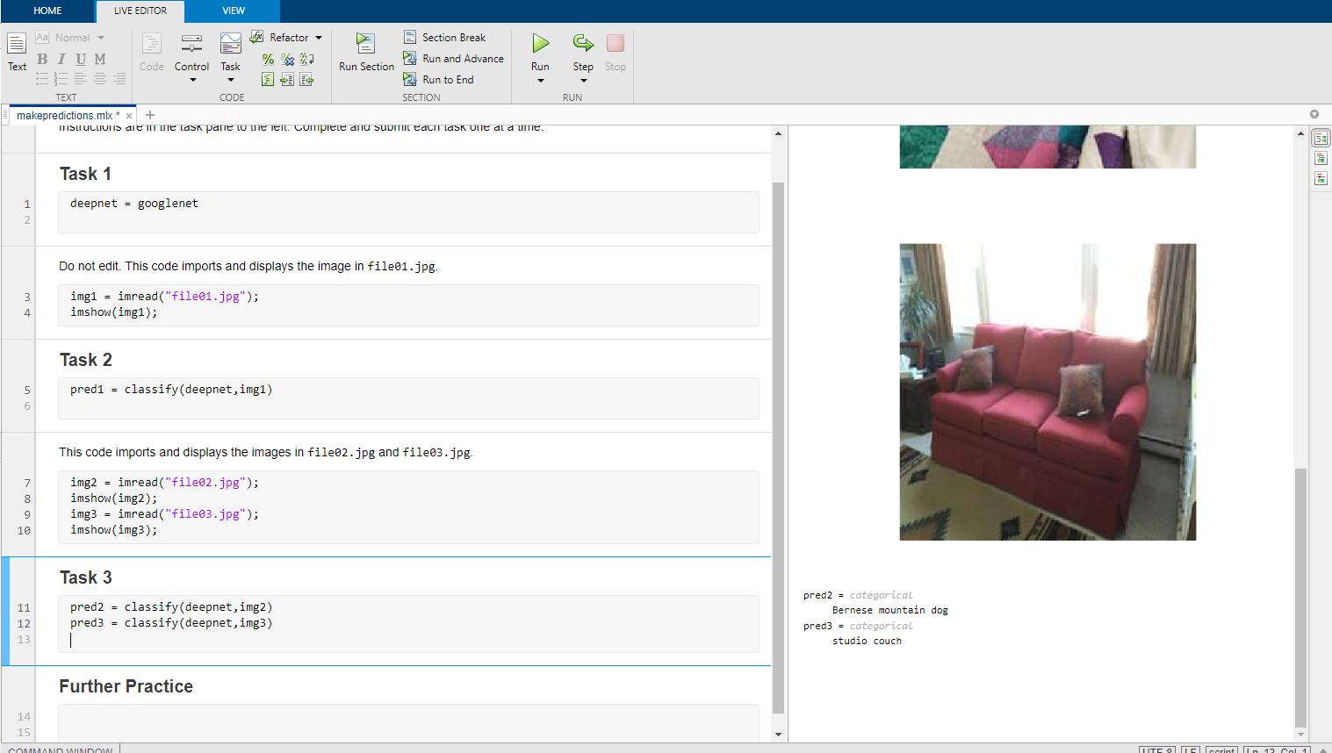

**References**

1. <https://matlabacademy.mathworks.com/R2021a/portal.html?course=deeplearning#chapter=2&lesson=2&section=1>
2. <https://www.youtube.com/watch?v=T2_iAEPijDc>
3. <https://www.mathworks.com/discovery/convolutional-neural-network-matlab.html>
4. https://www.mathworks.com/matlabcentral/answers/421259-why-should-i-choose-matlab-deep-learning-toolbox-over-other-opensource-frameworks-like-caffe-onnx